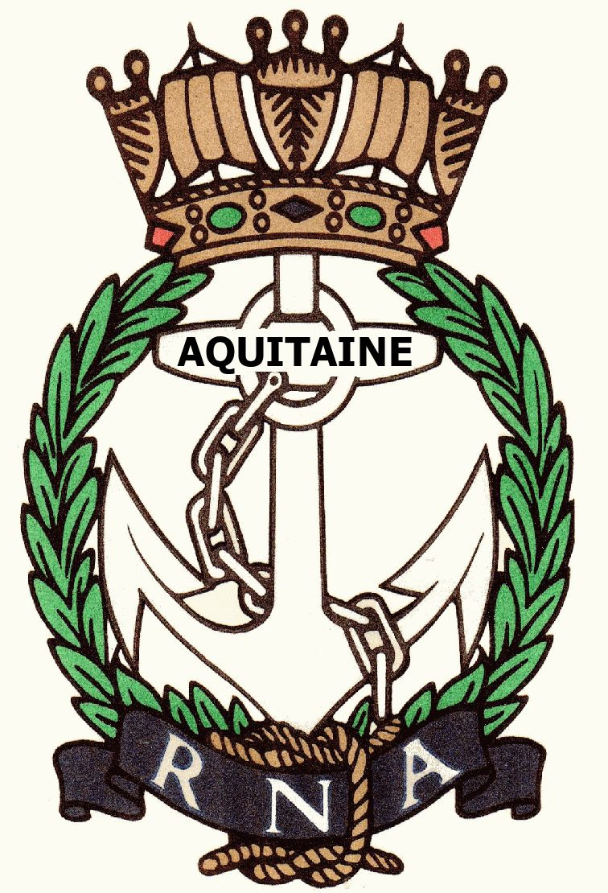
AQUITAINE BRANCH – ROYAL NAVAL ASSOCIATION
Chairman Shipmate Ken Napier MBE
Chazarem, 47290 Beaugas
Email napier.chazarem@wanadoo.fr Tel/Fax 05 53 01 72 80

MINUTES OF THE ANNUAL GENERAL MEETING HELD AT L’ETOILE, ST NEXANS, ON WEDNESDAY 11TH JANUARY 2017

- MEMBERS PRESENT: Henri Kastelein, Jeannette Kastelein, Gareth Mulloy, Ken Napier, Sue Napier, Dave Pegg, Don Pike, Dave Rolfe, David Rollston-Smith, Anne Scanlan’
- APOLOGIES: Chris Barnacle, Mike Beale, Bee Brown, Mike Brookes, Ken Checkett, Val Clarke, Ernie Coster, Martin Door, Hazel Door, Robin Faulkner-Smith, Fred Gosling, Tony Gribbon, Antoinette Henry, Geraldine Jackson, John Larmuth, Angela Larmuth, John Mills-Baker, Judy Mills-Baker, Mike Minter, David Pearson, Kate Pearson, Ray Pemble, Di Pemble, Gerard Vauxion
- APPROVAL OF MINUTES OF AGM 2015: The minutes of the previous AGM were approved. Proposed Dave Rolfe, Seconded Don Pike.
- ELECTION OF COMMITTEE: The Chairman, Vice-Chairman, Secretary, Treasurer and Assistant Treasurer were all happy to continue. There were three posts to be filled, two of which, Assistant Secretary and Welfare Person had volunteers: Don Pike as Asst Secretary and Liz Rolfe as Welfare Person. These posts were approved – proposed Gareth Mulloy, seconded Dave Rolfe. The post of Raffle Organiser is still open.
- CHAIRMAN’S REPORT: The Chairman began by stating that membership on 31st December 2016 stood at 45 Full Members and 38 Associate Members plus one Life Member and 1 Honorary Member. Three members crossed the bar in 2016. The agreed ratio of full members to associate members is 4:3 but due to deaths and members returning to UK or not renewing their membership this is not true of the present numbers. Socially the lunch numbers were down on average – 37 in 2015 and 30 in 2016. The most popular lunches were the Trafalgar lunch, the Queen’s 90th birthday lunch and the Christmas lunch. The monthly lunches varies from 16-26 euros and the Chairman thanked all those who either suggested and/or organised lunches. The standard was paraded at Monteton on 13th November, on the 11th November in Bergerac and in Bordeaux for the Cockleshell Heroes commemorations. The Chairman thanked the individual members of the committee for their help and support over the year. Due to the reduced numbers of people attending the lunches the raffle takings were down slightly. This money is used for Branch champagne for those who have been ill, for cards and flowers, wreaths for funerals and general welfare expenses. The surplus is donated to service charities. John Mills-Baker, the librarian, is unable to bring along our quite extensive library, and although books can be ordered on line from him, this is not happening. RFA WAVE RULER is still our affiliated ship. At present she is under the command of Captain Bob Allan, and is in UK waters as School ship for Flag Officer Sea Training. Captain Nigel Budd, one of our affiliated members is in command of RFA WAVE KNIGHT, currently in the Carribean. The three other affiliated members are Cdr Darren Houston who is XO of HMS QUEEN ELIZABETH, Lt Cdr Alex Meyer, currently at NORTHWOOD, and RM Commando Jack Lithgow who is training instructors at LYMPSTONE. The RNA postage stamps, managed by Ken Ayling, remain popular. The RNA’s monthly letter is available online and is available under ‘Members Area’ on the home page. A vote of thanks was given to Brian Johnson for managing our branch website, see above, this receives worldwide hits. The Chairman concluded by wishing everyone a very Happy New Year.
- TREASURER’S REPORT: Less people means less income through subs. In 2016 the total income from subs, raffles, donations, sale of stamps was 3516.30€. Our total expenditure including 6.50€* (£5) per head sent to HQ, charitable donations and running costs was 3033.40€. It was pointed out that the sum to be paid to HQ per person will rise to 8.50€* (£7) this year. (* This is dependent on exchange rates). Total money in accounts is 4100€. It was agreed that our reserve should be kept at a minimum of 2000€. Auditors for 2017 will be Don Pike and Henri Kastelein.
- ALLOCATION OF FUNDS: Mindful of the advice given by the Treasurer above, it was decided to send the same amounts to our recognised charities as last year: 500€ each to the RNBT, WRNSBT and ARNO and 300€ to SSAFA. In addition an extra 100€ is to be sent to WRNSBT in memory of Pam Ayling. RENA had flowers, John Murphy a charitable donation.. Proposed Dave Pegg, seconded Don Pike.
- SOCIAL PROGRAMME: The Trafalgar Lunch will be on Wednesday 18th October. An invitation to speak is to be sent to the Naval Attaché, Captain Keri Harris RN, and a decision on his attendance as speaker to be confirmed by 21st April. If he cannot come/commit Don Pike can then invite either Cdre Tony Morrow or Captain Peter Franklin to be our speaker. Liz and Dave Rolfe offered to host a lunch in June at their house as they did last year; this would be on Wednesday 14th June. The Moderne in Villereal was proposed by David Rollston-Smith as a possible lunch venue for 2017.
- RECRUITING: Because the ratio of full members to associate members is out of kilter members are encouraged to persuade any naval friends and acquaintances to join. A letter to the Connexion was also suggested.
- LIBRARY: The future of the library is undecided. It does not fulfil its function at present. It was decided that to begin with Ken will collect the fiction paperbacks from John Mills-Baker and take them to the next lunches for people to help themselves, the rest to be donated to the SSAFA book sale. The Royal Maritime Club has expressed interest in some of our Naval books. They are to be asked which books they are interested in and decisions will be taken after that.
- ANY OTHER BUSINESS: There was no further business. David Rollston-Smith gave a vote of appreciation to the Chairman, Ken Napier, for his work during the year.

The meeting closed at 1205.

COMMITTEE

Chairman - Ken Napier
Vice Chairman - Ken Ayling
Secretary - Sue Napier
Asst Secretary - Don Pike
Treasurer - Dave Pegg
Asst Treasurer - Ray Pemble
Welfare - Liz Rolfe
Raffle Organiser - ????

